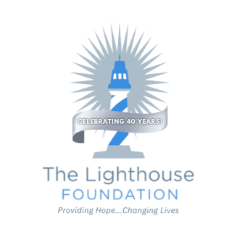
July 2025 / 10th Edition The Lighthouse Foundation Newsletter
“No act of kindness, no matter how small, is ever wasted.” – Aesop

Volunteering isn’t just about lending a hand—it’s about opening your heart. Whether it’s delivering groceries to a neighbor, mentoring a child, serving at your local non-profit or simply sitting with someone who feels alone, the kindness you offer can echo far beyond the moment. I’ve seen firsthand how a volunteer’s simple gesture has sparked hope in someone who felt forgotten. These moments may seem small, but they carry the power to change a life—and sometimes, even save one.

Here is one of our own stories: A Changed Heart Through Kindness
A 15-year-old boy came to us for community service hours. He arrived with a tough attitude and made it clear he wasn’t thrilled to be there. But instead of reflecting his attitude, our volunteers showed him kindness—simple, steady, and sincere. They welcomed him, encouraged him, and treated him with respect. Slowly, his guard came down and one day, he surprised us all by asking for some prayers. That small, brave moment marked a real turning point. He wasn’t just serving hours anymore—he was opening his heart. His attitude began to change. He smiled more, talked more, and hopefully he will be able to help others going through tough times.
Kindness is the heart of each volunteer here at The Lighthouse Foundation and it does change lives ~Your Sister in Christ, Lee Ann
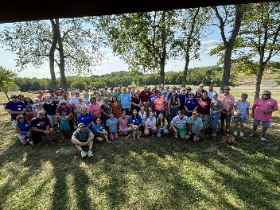
2025 Dates and Updates:
Volunteer Picnic – July 18th Adams Township Community Park/Rotary Pavilion

4 pm to 6 pm
There is still time to signup for the Volunteer Appreciation Picnic
Go to the website to get signed up today! We need your smile in next year’s picture!
40th Anniversary Gala – Pgh Marriott North Cranberry September 12th
Updates: 2024 Volunteer Picnic
BINGO - Raised almost $5,000 THANKS to everyone who helped, attended or promoted our 1st time ever BINGO

Golf Outing - Monday, June 23rd at Cranberry Highland Golf Club

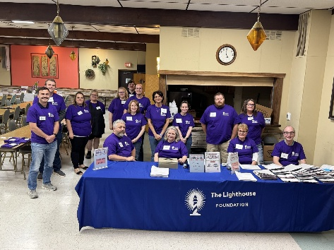
Raised $59,426/almost 10k over goal

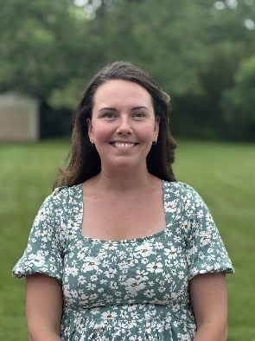
Food Pantry Stats (April / May / June)
Unduplicated Families Served – 2,247
Individuals fed through our food ministry – 6,237
New recipients – 246 households/ 300 individuals
Greater Pitt purchases - $ 4,984
Retail Store pickups – 138,115 lbs
Food Donations – 4,470 lbs
Waste – 3,685 lbs 3% (farmer picks up), 2025 Bingo Volunteers

Housing News Chloe
Meet our newest staff member Chloe! She is the Lighthouse Littles Coordinator.
We are still looking for childcare volunteers.
If you are interested in this new ministry watch for our meet and greet with Chloe in our new space coming soon
or reach out to Lee Ann

Whole Life Ministry (WLM) News and YTD Stats
47 families received rental $$ or security deposit, 17 families were helped with utilities,
and 9 people got help with car repairs and 4 families purchased a car with the help of WLM this year.
The need for WLM has increased, so the ministry is going digital to allow access for homebound clients and others with transportation issues. Starting next month, applications will be online for clients to fill out before their meeting.

Thank you 2025 Civic and Community Groups
Pine Richland HS Hockey / BCF YMCA / Cranberry Ladies Club / Cross Roads / Rich Mar Satellite Rotary / Butler High School / Key Bank / Baird-Carlson Group / Community Alliance Church / Knoch HS Girls Basketball / Good Samaritan Hospice and Concordia

