
April 2025 / 9th Edition
The Lighthouse Foundation Newsletter

Making space and planting seeds! The freshness of spring is in the air, and we see it everywhere! You can witness spring sprouts pushing through to become part of a beautiful landscape after months of hibernation. We observe it here as well. Spring is the time when organizations begin to consider giving back, planting seeds of kindness. Each of our volunteers yes, YOU, do an incredible job every day, loving and serving our community, but there are moments when we need you to step aside and allow groups to see what God is doing here. We understand it can sometimes be difficult not to be present and we appreciate your dedication to wanting to help, but we always trust God to provide a way to serve not only our clients but also fellow volunteers. An example of the ripple effect generated by these (volunteer) groups was when we were recently featured in a local newspaper article. It happened because the group cleaning for us recognized there was a story here. We are not done yet; we need many ambassadors to ensure everyone in our area knows about our services and Jesus’ love for them. It is also important to mention that we are primarily funded by individual and private donations, so it is crucial to continue raising awareness to allow funding to grow with God’s plan for The Lighthouse Foundation.

So, THANK YOU for making space and allowing others to be part of The Lighthouse Foundation and our programs. Enjoy those days off and utilize them in the best way you possibly can, knowing we certainly can see the sprouts peeking through here daily. ~Your Sister in Christ, Lee Ann


2025 Dates to remember and other ways to get involved:

BINGO – Highfield Hall in Butler, May 3oth – Doors open at 5pm


Lighthouse Littles Grand Opening – May 1st – 10 am to 2 pm 90 Kaufman Drive


Golf Outing - Monday, June 23rd at Cranberry Highland Golf Club
Volunteer Picnic – July 18th Adams Township Community Park/Rotary Pavilion – 4 pm to 6 pm
40th Anniversary Gala – Pgh Marriott North Cranberry September 12th
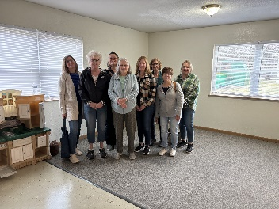
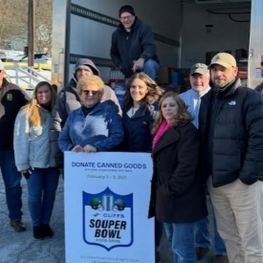
Food Pantry Stats (January/February/March)

Unduplicated Families Served – 2,176
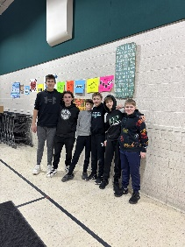
Individuals in our community fed through our food ministry - 5,869
New recipients – 258 households/340 individuals
Greater Pitt purchases - $6,564
Retail Store pickups – 105,173 lbs
Food Donations – 8,502 lbs
Waste – 4 % (farmer picks up)


Volunteers:
We have several new and fun opportunities on our website. Please scan the QR code if you wish to download the VOMO app to your phone or visit our website from your computer to explore all our options.
Use invitation code: THELIGHTHOUSEFOUNDATION

Whole Life Ministry (WLM) News

4 families have purchased a car with the help of WLM.

23 families were assisted with rent, 1 with utilities, 4 with car repairs this quarter.

Housing News
We will be launching the Lighthouse Littles program in early May
We need childcare volunteers to help T/W/TH 10 am to 2 pm
If you, or someone you know, is interested in our childcare ministry, please reach out to Lee Ann.

Thank you 2025 Civic and Community Groups
Pine Richland HS Hockey / BCF YMCA / Cranberry Ladies Club (See pictures above)

