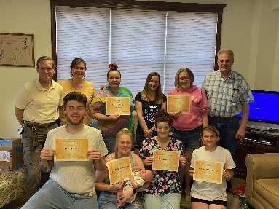
January 2024 / 4th edition of THE VOLUNTOLD

The Lighthouse Foundation Newsletter
Welcome to our 4th quarterly Newsletter!
John 15:15 “No longer do I call you servants, for the servant does not know what his master is doing; but I have called you friends, for all that I have heard from my Father I have made known to you.”
It is the 1-year anniversary of the “Voluntold”. I hope you’re enjoying it, and finding it useful. I say this because it is close to the 1-year anniversary of me being the “Volunteer Coordinator”. I have been so blessed to be able to focus all my energy on YOU and all things YOU do for The Lighthouse Foundation. As I reflect over the last year the one thing that stuck out to me is the overwhelming sense of community and fellowship you all have for each other. A sense of community that Jesus calls us to and encourages us to share with others. He calls us his friends first, and therefore we can share the joy of His friendship with those who come through our doors. I hope you all feel the same sense of brotherly/sisterly friendship I feel when I see each of you. Please feel free to reach out to me with any thoughts, ideas, or feedback that would help us better reflect Jesus to each other and to those we serve. ~Your Sister in Christ, Lee Ann
2024 Save the Dates & Updates (also check out the Volunteer Bulletin Board)

Golf Outing – May 20th at the Cranberry Highlands *

Soaring for Hope Gala - September 13th at the Butler Country Club *

*We need committee members for both events, if you interested or know someone,
please reach out to Lee Ann and let her know.

Food Pantry Stats (October / November / December)

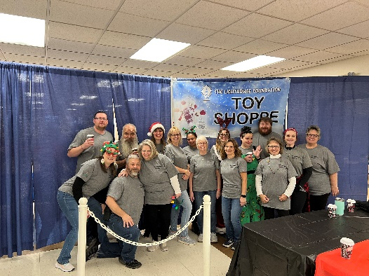
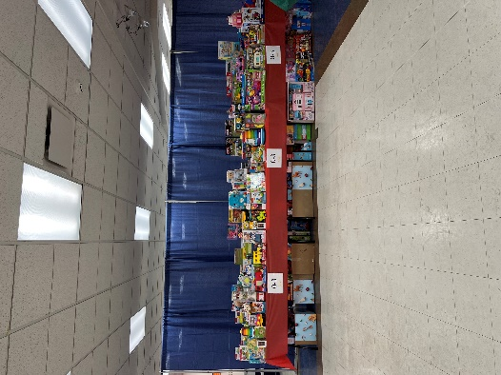
Donations:
2023 Toy Shoppe Committee
Retail Stores: 96,075 lbs
Other Donors: 5,733 lbs
Orders distributed: 3,132
Families impacted: 2,475
Individuals impacted: 6,751
New Families added: 306
4,206 lbs waste(4%) / farmers pickup
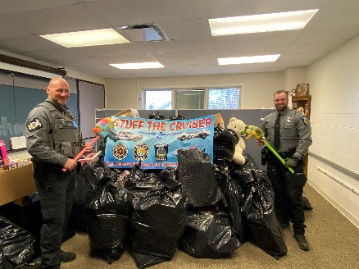
Volunteers:

October — 105 volunteers (9 new) completing 1,672 hours
November — 120 volunteers (14 new) completing 1,703 hours
December — 104 volunteers (12 new) completing 981 hours

Prayer Partner News - 627 Bibles were distributed last year

Tuesdays 3pm to 6pm are still available. Do you know a person, small group or church?

Other Lighthouse Program News

Toy Shoppe Served over 200 families and 500 children - Big “THANK YOU” to everyone who helped with this event.

Our Transitional Housing Program currently:
Johny’s Place (recovery house) – 2 residents / Amour (family dwellings) – 2 families including 2 children /
Penney House (single Male home) – 2 residents / Kaufman Drive (single parents) - 4 single parents including 11 children /
Blanchard House (single female home) – 2 residents

Residents started “Faith and Finance” on January 10th.

Thank you 2023 Civic and Community Groups
Gospel Life Fellowship / Cranberry Sunrise Rotary / Cross Roads Church / Cranberry YMCA / Concordia / Good Samaritan Hospice / Baird – Carlson Group / St Luke’s School / Camp Crestfield / Boy Scout Troop 19 / Mars Bank / First United Methodist of Butler /
Westminister Presbyterian Church / Samsung Electronic of America / Baird / Herbein

